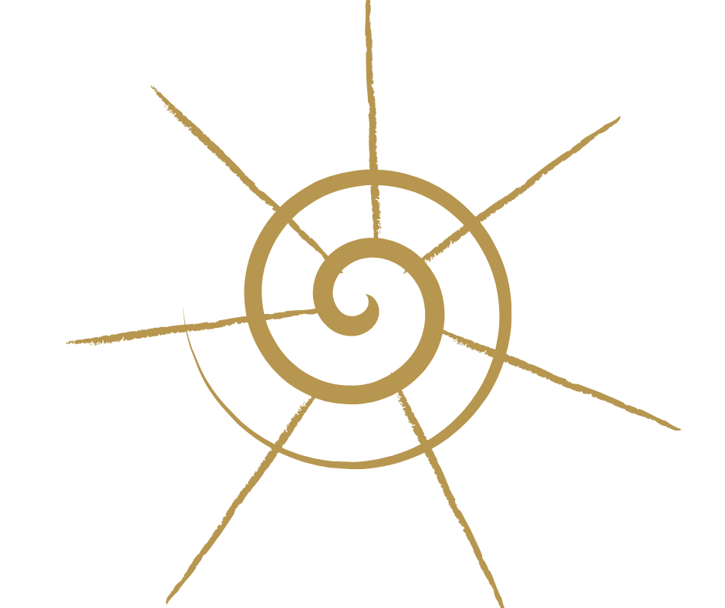

**WHAT ARE THE AKASHIC RECORDS?**

The Akashic Records or the Akashic Library is a dimension of consciousness that contains a vibrational record of every Soul and its journey, also all the Records for our planet.  The feel of this energetic field is extremely refined, crystal clear, sparkling clean and imbued with unconditional love, personal safety and genuine goodwill.  When I teach people how to enter the Akashic Library they often burst into tears from the sheer intensity of love and connection to their Soul Truth … very beautiful and a little bit scary the first time … but safe, always very safe and loving.

The word “Akasha,” is a Sanskrit word meaning “primary substance” – ‘that out of which all things are formed’ and from the perspective of the Records all Souls are eternal and the Akasha energy itself, although interpreted in different ways by different cultures, religions and organized belief systems, is generally recognised as love, light, peace, power, beauty, harmony, joy, strength, order and balance.   The Records are known in every spiritual tradition. For example, in the Judeo-Christian tradition as both “The Book of Life” and “The Book of God’s Remembrance.” On a simplistic level, it is like a library in the sky maintained and protected by Light Beings.  In fact this is how I first discovered the Akasha, by dreaming as a young child of being escorted into a library and pulling out scrolls to read, sitting in a circle with ‘tall men in robes’ and being talked to at length and in great details about various events, planetary and personal.

**AKASHIC SOUL RECORDS READINGS**

Reading the Akashic Records is not fortune telling, it is retrieving actual information from a person's Soul Records to accurately target the real causes & solutions for current 'problems'. The ultimate goal of accessing this profound source of Wisdom is to release each Soul’s highest potential. The information garnered is specific to the questions asked by you and can range from everyday answers to practical questions … to resolving deep karmic ties and lifetime patterns (current and past).  Whatever comes up during your Akashic Earth reading - your own journeying into the Akashic Field, … no matter how confronting please be assured the whole process is extremely gentle because of the attention paid to setting up a safe space and vibrationally matching you with integrity .… it is healing on a deep level and exquisitely beautiful to experience. Know that whatever information and healing comes to you in your personal Akashic Earth process is exactly what you need, or need to know, at this point in time - in order to resolve the current crisis and better understand your personal Soul journey.  Clarity, peace and joy are common states after an Akashic Earth visit. People’s lives are genuinely changed for the better and they often report back that they feel they are functioning at a higher level in their daily lives. I actually like to start my day with a 30 min visit to my Akashic Earth Records – it sets me up beautifully for the day.

**HEALING IN THE AKASHA**

More often than not, healing is required around stuck patterns (emotional/mental /physical /spiritual) that arise for clearing during an Akashic Earth visit.  If you have other skills, feel free to use them whilst in your Records … Reiki, Hawaiian ho’oponopono, sage smudging, feathers, crystals … whatever tools you possess to ‘clean’ patterns whilst in the Akashic Field can be used. The need for healing can arise at the beginning, middle or end of a reading depending on each Soul’s point of journey in this lifetime. Often healing will also be sent to another Soul with whom you have, or had, an issue. E.g.: if a relationship has recently split, you may require healing around anger and the other party may require healing around grief or vice versa. Sometimes you will even find that this clearing has to be done before the Akashic Earth Field will allow you to commence with your questions. So, if you find yourself ‘stuck’ during a session … apply a healing technique, or just ask for a healing chamber … then ask again to be shown the relevant information. Relax and enjoy the process – just as the Universe wasn’t created in a day, neither were you.

**WHAT IS THE AKASHIC EARTH FIELD?**

A long long time ago, in the fall of Atlantis the codes (or keys) to the Akashic Records were handed to the whales for safekeeping. Now we are in a time when the Earth (Soul Gaia) wishes to reconnect with the Akashic Field and raise her vibration so we can enter an age of Peace and Prosperity. It has been my job, the primary purpose of my incarnation, to facilitate this process - to receive back the Akashic codes for humankind and reconnect them to Gaia. I thought it would be a complicated drawn out technique involving swimming with whales all over the world and I often wondered when exactly I would go on this wondrous journey. I regularly commune with the whales as they pass through the beach where I live but never felt the urge for anything beyond that. Then it just happened one day when I was doing a healing for a distance client in another state … there was a whoosh and the Akashic Field landed back on Earth, eerily simple and profound at the same time. So now we all have easy access to the Akashic Earth Realm, reconnected for the benefit of all, including Soul Gaia. This reconnection has made life a lot more comfortable for healers generally – I know I certainly feel at home now in my everyday life instead of constantly struggling to do my best in a difficult world that doesn’t vibrate to the same frequency as me. It has also made Akashic Earth knowledge and healing much easier to access. It is from the Akashic Earth Field that I have channelled the process for Akashic Earth Reading and Healing that you are learning with me in this course. You will find that by doing the Akashic Earth Process regularly, you will be able to manifest authentic truths, daily healing and stay on your path more easily in general. I have created this technique but it will become your process now.

**VALENTINA’S STORY**

When I was a child I used to go into the ‘library in the sky’ in my dreams and sit in a circle of very tall, robed men and talk about all sorts of things. We would pull scrolls out of the library and read them. The information was all about my family’s history back to the beginning of time, detailed information about our planet and a lot of information about how to ‘fix things’ and right wrongs, how to re-set all the equations that relate to our planet. I also had many other pre-cognitive dreams that made it difficult in my waking world to determine what had actually occurred. I was often confused by events in my daily life that I thought had already happened (because I had dreamed them) and couldn’t understand why people were surprised or upset. Sometimes I also couldn’t differentiate between living and passed Souls because they looked the same to me and being a child, they just chatted normally to me about this and that, no particular bells and whistles, no special messages but once again it confused me, e.g., I couldn’t understand the grieving process or funeral masses when as far as I was concerned the person everyone else was grieving over was not dead at all, I thought everyone had made a huge mistake. In retrospect, I must have been a strange child. Not that psychic ability or seeing dead relatives was an alien concept in my matriarchal Irish/Welsh family. Grandma’s spirit inhabited our home in Auckland, New Zealand (often seen at the end of the hallway), and when we moved to Australia, she went to live with one of my sisters. Being ‘fae’ (what we now generally call psychic) is just part of being Irish, especially before death. They know when someone is preparing to pass over because they become fae. My great-grandmother was a healer who travelled the countryside (in Ireland) laying her hands on injuries and setting bones. She was highly regarded - wild and wonderful. She died in a horse and buggy accident (she was driving the horses too fast). I feel very strongly that my empathic healing gifts come from my mother and her sisters and generations back of soft but strong women from Nenagh in Ireland. Their ability to understand and embrace all types of people is amazing and inspiring.

In my teens I gravitated to various spiritual groups in an endeavour to understand my dreams and the colours I saw in and around people – auras or electromagnetic energy fields. I now know we all have an energetic body that exactly mirrors our physical body. I call them Rivers Of Light after ancient Mayan Shamanic healing techniques. No one group or another really resonated with me.

Fast forward to me in my 20s attending a live-in 5-day Sand Play Therapy course in the Blue Mountains, north of Sydney, Australia. One morning I was looking tired and announced how exhausted I was. One of the wonderful older women asked me if there were emotional issues coming up for me that stopped me from sleeping.

Before I even realised the words were out of my mouth I said “No! I have been in the library in the sky all night! I read all this information about all of us, the equations

that make our lives work … and I can’t remember any of it!” She sat me down and got me to explain about the dreams I have had all my life and then told me it was the Akashic Records and this is a very valuable and rare gift I have, a gift that is sought after by many people. She really impressed on me how valuable my gift was. I was overwhelmed, enrolled in art school and never spoke of it again … or so I thought.

But the dreams didn’t stop. After a while I shared knowledge with friends, gave them tips, insights and warnings. I got to a place of understanding that the Akashic Library dreams helped to give me an extra dimension of understanding of our 3D reality. I gravitated towards energetic and crystal healing and consulted therapists to heal various aspects of my own personal pain in this lifetime. I always felt like the mermaid from childhood stories who chose to live on land with her beloved Prince … with the price being that she always felt like she was walking on knives. Then one day a few years ago I was looking through one of my favourite online spiritual bookshops and saw a book by Linda Howe “How to read the Akashic Records”. I thought ‘this will be interesting’ and purchased it. In the book, Linda shares a Pathway Prayer that she sought permission from the Lords of the Akasha to publish for general use. It was wonderful! It enabled me to meditate, walk across to the Akasha for healing, guidance, time with my Soul family and then simply walk back again … and all done in daylight!

I now have developed my own Akashic Earth technique but still value Linda’s work.

**WHAT DOES THE AKASHA FEEL AND LOOK LIKE?**

To me it often feels like powder snow softly falling on powder snow – very still, refined and inherently beautiful. The colour is blue, kind of like a cross between cornflower blue and royal blue. There are many levels of knowledge, healing and information; it would be impossible to describe all the chambers I have seen. The information is always correct, I have a saying about being put on your true path by Akashic guidance … once you have the knowledge … you can run but you can’t hide! Your guides will find a way to push you back on to your path.

**WHAT IS MY PRIMARY REASON FOR INCARNATING, MY LIFE PURPOSE?**

In the fall of Atlantis, the codes (or keys) to the Akashic Records were handed to the whales for safekeeping. Now we are in a time when the Earth (Soul Gaia) wishes to reconnect and raise her vibration so we can enter an age of Peace and Prosperity. It has been my job to facilitate this process - to receive back the Akashic codes for humankind and reconnect them to Gaia. I thought it would be a complicated drawn out technique, but it just happened one day when I was doing a healing for an amazing client, (who just happens to be in my Soul Group). In many ways my gift to you is “Akashic Earth Reconnection”.

Thank you for reading my story; I am honoured by your attention to my journey and send you Love and Light for your journey.

**WHAT IS YOUR STORY?**

**PROCESS OF ACCESSING THE AKASHIC EARTH FIELD AND LIBRARY**

Feel who you are right now … 3 big breaths, exhale through your Heart Chakra

– your AE bag is on your chest, on your Heart Chakra.

Use your AE Sun Symbol to form a shield of protection around you

– top, bottom, front, back, both sides and project into the centre of the room.

Take 5 or 10 minutes to connect yourself to your personal Spirit Consciousness through your Sun Star - imagining it above you and bringing a shaft of Light from it into each Chakra and drawing into each chakra your AE Sun Symbol, and your Totem.

Feel/enjoy the vibrations.

Pull AE energy up from the crystal centre of Gaia – imagine drawing the AE Sun Sign on the soles of your feet, and also your Totem. Then visualise the Mothers & Grandmothers vibrating Akashic Earth energy up to you … up through soles of your feet, throughout your whole body, down your arms and back into the earth. Create a cycle of energy - flowing up to you, in and around and down under the Mothers and Grandmothers, through the Akashic Earth and up to you again.

Do the Soul Source meditation - Ball of Soul Light above you, then around you, a Soul Light platform under you.  Soul Light sinking through your energy fields, all through your body.

Magnetically pulling out whatever is no longer required in your life.

Magnetically emanating into you whatever it is you require at this point of your life.

Allowing your Personal Soul Light to do its work of cleaning and preparing you.

Say the Akashic Earth Invocation to access your personal Akashic Earth Records.

Move forward with your Totem animal into the Akashic Earth Library and ask for specific Records, receive healing, connect w Soul Self, etc. Remember to ask your Akashic Totem to assist.  You can also say 'Masters, Teachers and Loved Ones please find the Records for ...'. Or you may travel around yourself. Allow whatever happens to happen, allow the information/healing to come to you in whatever form it wishes to come … just like you allowed the Soul Light to clean you in preparation.

Say the 'Returning to Surface' Invocation to close the Akashic Earth Records.

If they don't feel closed, clap your hands 3 times to bring yourself back into present awareness.

**PERSONAL SOUL LIGHT CLEANSING AND PROTECTION MEDITATION**

This meditation is to connect you to Divine Love and Light, to Soul Source.

Imagine above your head a ball of Light about the size of a basketball – it could be any colour, allow whatever it is today to just be that. This is your personal connection to Divinity, to Soul Source. It is always there but we don’t always take the time to look at it. It is pure Divine Soul Light floating there just above your Crown Shachara and you could almost reach up and touch it. Look up at it now and notice WHAT it looks like – this Divine Light, Unconditional Love, Unlimited Goodwill, Universal Intelligence that is you, the I Am – what does it look like this vibrating ball of Soul Light …… and how do you FEEL inside when you look at it? Notice any emotions, physical sensations, thought patterns, and memories that come up for you. Acknowledge them and let them go. Looking at this ball of beautiful Soul Light … just looking at it in wonderment and feeling at peace with it being there …. See now Light flowing out of your ball of Soul Light like a waterfall flowing all around you but not touching you – it flows around you and closes underneath you forming an oval shape of sparkling Divine Soul Light around your body.

Notice also that there is a huge amount of Soul Light swirling underneath you, flowing and swirling like a soft fluffy cloud for you to rest on and be supported by as you experience your personal Akashic Earth Field today. So there you are, enclosed in your waterfall of personal Soul Light that has completely sealed around you (but not touching you) and also supported in your Akashic Earth session today by a strong platform of Soul Light underneath you.

Then in your own time allow the Light to flow gently towards you – very slowly and gently passing through your electromagnetic energy fields until it reaches your skin, your energy fields are being washed clean with your own personal Divine Soul Light – ahhhhh they would be in ecstasy! Literally feeling loved by your True Self.

When the Light reaches your body allow it to pass through this physical boundary of your skin and into your body, filling up your whole body with Divine Soul Light. Soul Light in your feet, your toes, your heels and your ankles, Soul Light in your calves and in your knees. Soul Light in your thighs, Soul Light in your pelvis, your belly, your posterior and your lower back. The energy of Soul Light right up your spine, your torso front and back, Soul Light spreading out into your chest, your upper back and shoulders. Soul Light in your neck and throat, Soul Light in your jaw and up the back of your head. Soul Light all through your head. Soul Light in your forehead, eyebrows, your eyes, nose, cheeks, mouth, chin and in your ears. Soul Light in your hair from the follicles right down to the ends, Soul Light on your scalp. Soul Light in your upper arms, your elbows, your lower arms, and in your wrists. Soul Light in your hands, your fingers, your fingernails and in all the little wrinkles that are part of our hands – in fact Soul Light in every cell of the largest organ in our body – our skin.

Soul Light in your brain. Soul Light in your heart … in your lungs, your kidneys, your liver and your spleen. Soul Light all through your digestive system and your reproductive system. Soul Light all through your blood, your muscles, your tendons, your nerves and nerve endings. Soul Light in every bit of fat in your body. Soul Light all around you and all through your body.

Now I want you to remain calm and just let the Light to do its work, it’s a magnetic force that wants to take out of you anything that no longer needs to be there – any emotional or physical pain, or pain attached to memories, mental thought processes that no longer serve you well …. Anything that no longer needs to be there can be pulled out by the Divine Soul Light now … just relax and let the Light do its work unhindered.

Considering the personal Soul Light contains unlimited goodwill for you and your journey in life it also wants to now give you whatever it is that you need in your life right now on an energetic level so once again just remain calm and let the Light do its work – this time the magnetic force wants to vibrate into you the ESSENCE of whatever it is that you need at this point in your life here on Gaia and for each of us that will be completely different …. So there you are in your waterfall of Divine Soul Light that has completely surrounded you and filled you up with Divine Soul Energy - just ALLOWING yourself to be healed – allowing yourself to be CONNECTED to your Soul Light, Your Soul Energy, - out with the stale, in with the fresh … just ALLOW this healing to happen … FOCUS on the Soul Light around you and in you.

**AKASHIC EARTH INVOCATION**

Akashic Earth Invocation – going within

I give thanks to my Higher Self, my Akashic Self and the Wise Mothers and Grandmothers guarding and safe keeping the Akashic Earth Field. Aho Gaia

I (say your full name) choose to vibrationally match with my personal Akashic Earth Records now - with my body, aura, and consciousness. I am (say your nickname), please welcome me. Aho Gaia

Unity Consciousness, please assist me to know every aspect of (state your query) in the vibration of the Akashic Earth Records, please welcome me. Aho Gaia

Unity Consciousness, please assist me to know all that I Am in the 8th dimensional vibration of the Akashic Earth Records, to trust the answers I receive are mine, the healing I receive is accurately targeted to my stated query, and that my Soul Wisdom is healing me in ways that are a vibrational match for me. I state this in reverence of all that I Am, please welcome me. Aho Gaia

My Akashic Earth Records are now with me | My Akashic Earth Records are now with me | My Akashic Earth Records are now with me.

*Allow whatever happens to happen, to be what you be in your Akashic Earth Records, ask your Totem for assistance and trust your journey, teachings and healings today are perfect for you.*

‘Returning To Surface’ Invocation

As I prepare to leave my Akashic Earth Records, I give heart-felt thanks to my Akashic Totem for assistance, my Higher Self, my Akashic Self, my Soul Self and the ancient Wise Mothers and Grandmothers for facilitating my vibrational journey within to all that I Am, to my Akashic Earth Records.

I receive my blessings with gratitude and honour the graceful Wisdom of the Masters and Guides who have helped me. Giving thanks to every aspect of me who I have met today. I say thank you, thank you, thank you as I prepare to return to my incarnated life, to ground back in my body.

Here and now, I return to surface and become like a tree growing strong with my roots in the Earth for sustenance, my trunk body supporting me … my Crown reaching up to the Sky for light.

Aho Aho Aho

I am back in my body and integrating my process now. Aho Aho Aho

Breathing, moving, writing everything down. Aho Aho Aho

